1. **Suppose that a data warehouse consists of the three dimensions time, doctor, and patient, and the two measures count and charge, where charge is the fee that a doctor charges a patient for a visit.**

* Design a star schema for such a data warehouse.
* Identifying the fact table(s) and dimension table(s).
* Identifying their primary key(s), foreign key(s) and measures.

1. **Suppose that a data warehouse for Big-University consists of the following four dimensions: student, course, semester, and instructor, and two measures count and avg. grade. When at the lowest conceptual level (e.g., for a given student, course, semester, and instructor combination), the avg grade measure stores the actual course grade of the student. At higher conceptual levels, avg grade stores the average grade for the given combination.**

* Design a Star Schema schema for such a data warehouse.
* Identifying the fact table(s) and dimension table(s).
* Identifying their primary key(s), foreign key(s) and measures.

1. **Suppose that a data warehouse consists of the four dimensions, date, spectator, location, and game, and the two measures, count and charge, where charge is the fare that a spectator pays when watching a game on a given date. Spectators may be students, adults, or seniors, with each category having its own charge rate.**

* Design a star schema for such a data warehouse.
* Identifying the fact table(s) and dimension table(s).
* Identifying their primary key(s), foreign key(s) and measures.

1. **Design the data warehouse for a wholesale furniture company.**

**The data warehouse has to allow to analyze the company’s situation at least with respect to the Furniture, Customers and Time. Moreover, the company needs to analyze:**

**the furniture with respect to its type (chair, table, wardrobe, cabinet. . . ), category (kitchen, living room, bedroom, bathroom, office. . . )**

**and material (wood, marble. . . )**

**the customers with respect to their spatial location, by considering at least cities, regions and states**

**The company is interested in learning at least the quantity, income and discount of its sales**

* Design a star schema for such a data warehouse.
* Identifying the fact table(s) and dimension table(s).
* Identifying their primary key(s), foreign key(s) and measures.

1. **Convert 3NF to Dimensional modeling**

* Design a star or snowflake schema for such a data warehouse.
* Identifying the fact table(s) and dimension table(s).
* Identifying their primary key(s), foreign key(s) and measures.

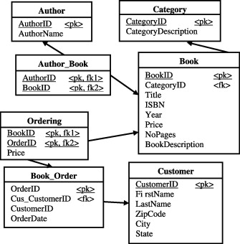

1. **Convert 3NF to Dimensional modeling**

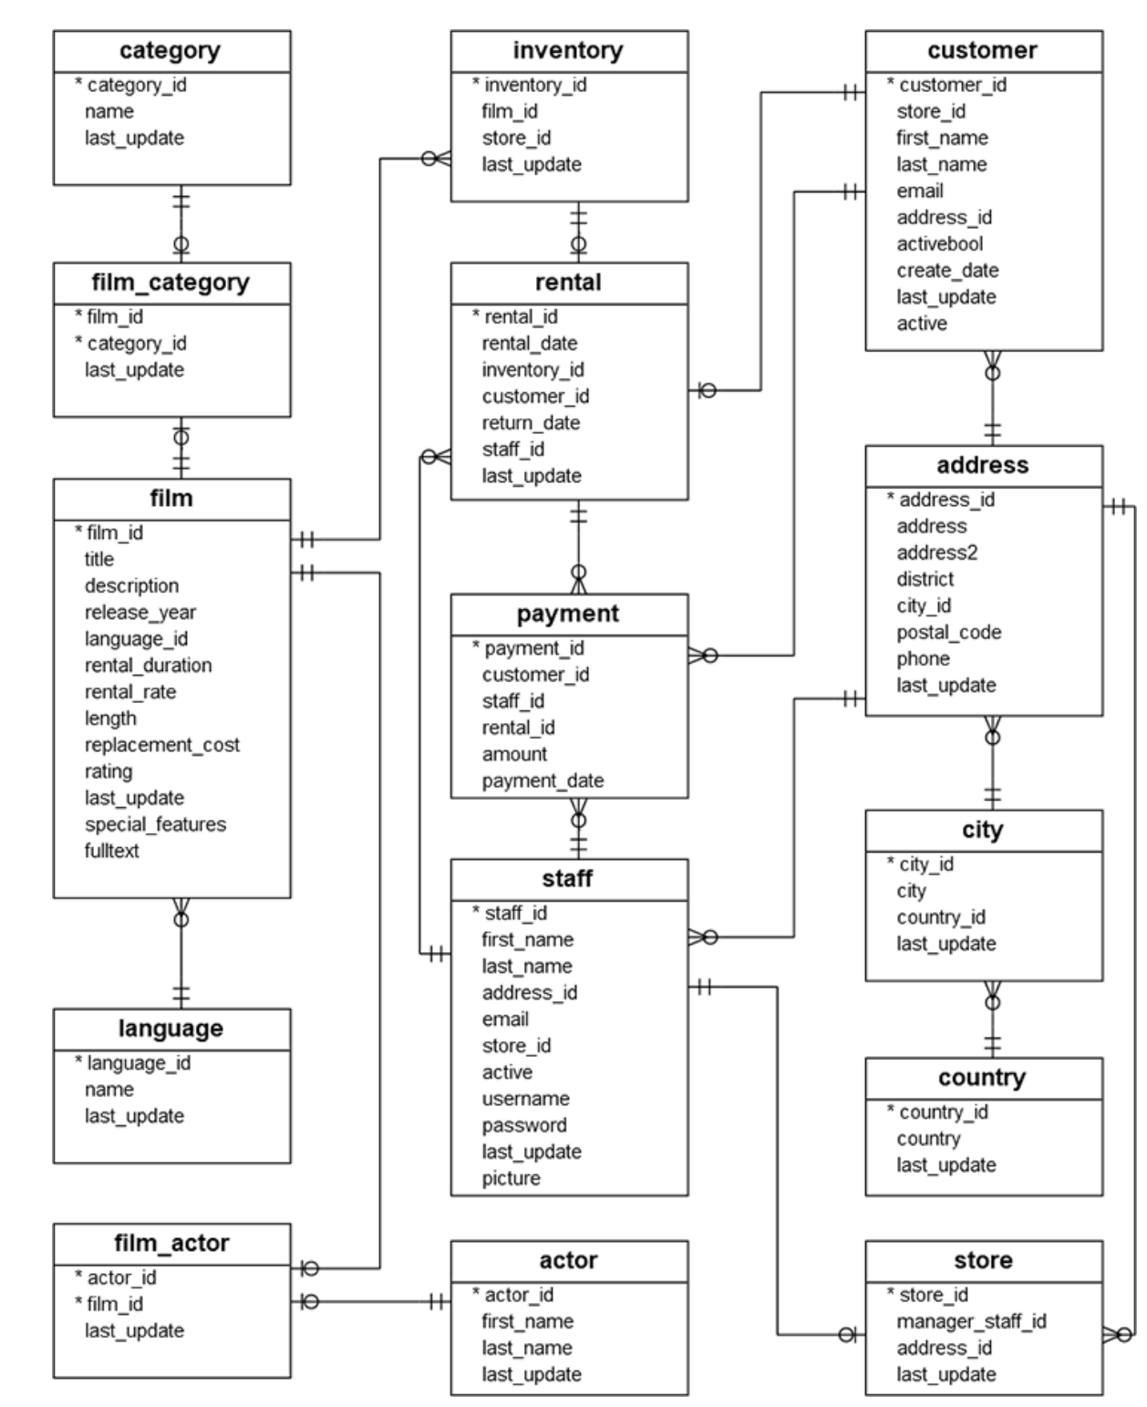

1. **Convert 3NF to Dimensional modeling**

* Design a star or snowflake schema for such a data warehouse.
* Identifying the fact table(s) and dimension table(s).
* Identifying their primary key(s), foreign key(s) and measures.

